**ONLINE BOOKSTORE**

**A MINI PROJECT REPORT**

***Submitted by***

**Group: G5**

**HARSHIT SOOD, 2410990335**

**HARSHITA, 2410990336,**

**HARSHITA GARG, 2410990337**

#### in partial fulfilment for the

#### award of degree

#### of

## BACHELOR OF ENGINEERING

***in***

**CSE**



**CHITKARA UNIVERSITY**

**CHANDIGARH-PATIALA NATIONAL HIGHWAY**

**RAJPURA (PATIALA) PUNJAB-140401 (INDIA)**

##### **SEPTEMBER,2024**

**ABSTRACT**

###### The rise of digital technology has transformed the retail landscape, giving birth to online bookstores that revolutionize how readers access literature. This paper examines the evolution, benefits, and challenges of online bookstores, focusing on their role in promoting literacy and expanding the market for authors and publishers. Online bookstores offer unparalleled convenience, allowing consumers to browse vast catalogs from the comfort of their homes, compare prices, and access user reviews, which enhance informed purchasing decisions. Moreover, digital platforms often provide a wider range of titles, including self-published works and niche genres that traditional bookstores might overlook.

###### This study also highlights the impact of online bookstores on traditional retail, discussing the shift in consumer behavior and the subsequent adaptation strategies employed by brick-and-mortar stores. Additionally, the paper explores the innovative features that online bookstores incorporate, such as personalized recommendations powered by algorithms, e-books, audiobooks, and subscription services, which cater to diverse reader preferences.

###### However, the proliferation of online bookstores is not without challenges. Issues such as market saturation, copyright concerns, and the environmental impact of shipping must be addressed to ensure sustainable growth in the digital book retail sector. Furthermore, the paper considers the implications of online purchasing on local economies and community engagement with literature.

###### In conclusion, while online bookstores have significantly reshaped the reading experience and access to literature, their continued success will depend on their ability to navigate the complexities of a rapidly evolving marketplace. By fostering innovation and addressing key challenges, online bookstores can continue to play a pivotal role in the future of reading and publishing.

###### TABLE OF CONTENT

|  |  |  |
| --- | --- | --- |
| **Sr.no** | **Sections** | **Page no.** |
| **1.** | Introduction |  |
| **2.** | Technical details |  |
| **3.** | Key features |  |
| **4.** | Project advantages |  |
| **5.** | Project highlights |  |
| **6.** | About us page |  |
| **7.** | Home page |  |
| **8.** | Future scope |  |

###### INTRODUCTION:-

###### The title of our project is “online book store”, and the team members are:-

###### Harshit sood, 2410990335

###### Harshita, 2410990336

###### Harshita garg, 2410990337

###### An online book store is a website that is designed while keeping the reader in mind, offering a seamless shopping experience that makes discovering and purchasing books easier than ever.

###### The application is developed using HTML and CSS. Our website is simple and intuitive. With well-organized categories, a powerful search function, and filters for genre, author, and publication date, finding your next great read is just a few clicks away. Each book listing includes detailed descriptions, reader reviews, and recommendations, ensuring you can make informed choices.

###### Online bookstores provide unparalleled convenience, offering a vast selection of titles that caters to diverse tastes and preferences. With the ability to browse from anywhere at any time, consumers can access everything from bestselling novels to rare finds, often at competitive prices. Moreover, digital platforms enhance the shopping experience with features like user reviews, personalized recommendations, and instant access to e-books and audiobooks.

###### In addition, we will examine the impact of online bookstores on literacy promotion and community engagement, considering how these platforms can both foster and hinder local reading initiatives. By assessing the benefits and drawbacks, this report aims to provide a comprehensive understanding of the online bookstore phenomenon and its potential future trajectory in the ever-evolving world of literature

###### PROBLEM STATEMENT:-

Reading books offers a multitude of benefits that enrich our lives in various ways.

It builds one’s personality, vocabulary, language skills and boosts their personal growth. Unfortunately, this seemingly simple task often presents significant hurdles like:

**1.Time Consuming** :

The process of manually searching for various genres of books, quality concerns can be time-consuming and cumbersome. Visiting a bookstore takes time, which can be inconvenient, especially if it’s far away. You must plan your visit around store hours, which may not fit your schedule.

**2. Higher Prices :**

Physical bookstores may have higher prices due to overhead costs, such as rent and staffing. You might miss out on deals and promotions available online.

**3. Limited Selection :**

Physical stores often have a smaller selection compared to online retailers, limiting your choices. Desired titles may be unavailable, requiring additional trips or waiting for restocking.

###### TECHNICAL DETAILS:-

###### HOME PAGE: of our website simple and intuitive. With well-organized categories, a powerful search function, and filters for genre, author, and publication date, finding your next great read is just a few clicks away.

###### Login form: A modal for user sign-in with fields for email, password, and a remember-me option, along with links for password recovery and account creation.

###### Featured: featured option highlight selections recommended by your team, offering personal insights and reasons for each pick.

###### Arrivals: in this section of our book store you’ll find the latest titles that have just hit our shelves, keeping you updated on the freshest literature in the market. This section is perfect for readers who want to stay ahead of the trends and discover new voices, stories, and ideas.

###### Reviews: we believe that every reader’s opinion matters. Our **Reviews** section is designed to provide valuable insights into each title, helping you make informed decisions before purchasing.

###### Blogs: Our blog is designed to enhance your reading experience, providing insights, recommendations, and a deeper connection to the literary world.

###### Secure payment methods: we prioritize your security and peace of mind when shopping online. Our range of secure payment methods ensures that your transactions are safe and your personal information is protected.

###### Technical Support: technical support in an online book store is essential for ensuring that users have a positive experience with the website. It helps users overcome technical challenges, provides guidance on using the website

**4.KEY FEATURES: -**

* **User-Friendly Interface:** A user-friendly interface is a key feature of any project. It helps users navigate through the project with ease and efficiency. A well-designed interface can make the difference between a successful and unsuccessful project. It is important to keep in mind that the interface should be intuitive and easy to use, even for those who are not tech-savvy. A good interface should be visually appealing, responsive, and provide clear feedback to the user.
* Featured: featured option highlight selections recommended by your team, offering personal insights and reasons for each pick.
* Arrivals: in this section of our book store you’ll find the latest titles that have just hit our shelves, keeping you updated on the freshest literature in the market. This section is perfect for readers who want to stay ahead of the trends and discover new voices, stories, and ideas.
* Reviews: we believe that every reader’s opinion matters. Our **Reviews** section is designed to provide valuable insights into each title, helping you make informed decisions before purchasing.
* Blogs: Our blog is designed to enhance your reading experience, providing insights, recommendations, and a deeper connection to the literary world.
* Secure payment methods: we prioritize your security and peace of mind when shopping online. Our range of secure payment methods ensures that your transactions are safe and your personal information is protected.
* Accessibility: Accessibility is an important aspect of any project. A well-designed interface should be accessible to all users, regardless of their abilities. This includes providing alternative text for images, using high-contrast colors for users with visual impairments. Additionally, it is important to ensure that the project is compatible with screen readers and other assistive technologies.

**5.PROJECT ADVANTAGES:-**

#### ****Convenience:**** Shop from anywhere, anytime, without the need to travel to a physical location. This flexibility makes it easy to browse and purchase books on your schedule.

#### ****Vast Selection:**** Access a wider variety of titles, including bestsellers, niche genres, and self-published works that may not be available in local stores.

#### ****Easy Comparison Shopping**:** Quickly compare prices, formats, and reviews across multiple titles, allowing for informed purchasing decisions.

#### ****User Reviews and Ratings:**** Benefit from customer reviews and ratings to gauge the quality and content of a book before buying.

#### ****Personalized Recommendations:**** Enjoy tailored suggestions based on your browsing history and preferences, helping you discover new authors and genres that match your interests.

#### Special Offers and Discounts: Take advantage of exclusive online promotions, discounts, and loyalty programs that may not be available in brick-and-mortar stores.

#### Detailed Information: Read in-depth descriptions, author bios, and publication details to get a comprehensive understanding of a book before purchasing

#### Easy Returns and Customer Support: Many online bookstores offer straightforward return policies and customer service options to assist with any issues or inquiries.

#### Reduced Overhead Costs: Online bookstores often have lower operating costs than physical stores, allowing them to pass savings on to customers.

#### PROJECT HIGHLIGHTS:

#### HTML and CSS code:

#### HTML CODE:

<!DOCTYPE html>

<html l<!DOCTYPE html>

<html lang="en">

<head>

    <meta charset="UTF-8">

    <meta name="viewport" content="width=device-width, initial-scale=1.0">

    <meta name="keywords" content="bookstore, books, books shopping, online bookstore, writers, authors, content, reading, readers' haven">

    <meta name="description" content="Readers' Haven: Your free online bookstore where you can binge your favourite novels or academic content. You can also order hardcopies or softcopies at best competitive prices.">

    <meta name="authors" content="Harshit Sood, Harshita Garg and Harshita">

    <title>Readers' Haven | Official Site</title>

    <link rel="shortcut icon" href="logo.ico">

    <link rel="stylesheet" href="stylesheet.css">

    <link rel="stylesheet" href="https://use.fontawesome.com/releases/v5.0.7/css/all.css">

</head>

#### OUTPUT:

#### 

#### EXPLANATION:

* **<!DOCTYPE html>:** This declaration specifies that the document is an HTML5 document.
* **<html>:** The root element of the HTML document.
* **<head>:** Contains metadata about the document and links to external resources like stylesheets.
* **<meta name="viewport" content="width=device-width, initial-scale=1.0**">: A meta tag that sets the viewport width to the device width and specifies an initial scale of 1.0, which is common for responsive web design.
* **<link href="stylesheet.css" rel="stylesheet>:** Links an external CSS stylesheet named "style.css" to style the webpage.

**HTML CODE:**

 <header class="header">

        <div class="header1">

            <a href="#"><img src="logo.jpg" class="logo" alt="Bookstore Logo" style="height: 120px; width: 120px; " /></a>

            <form action="" METHOD="get" class="search-form">

                <input type="search" name="" placeholder="search here...." id="search-box">

            </form>

        <div class="header2">

            <nav class="navbar">

                <a href="#home">home</a>

                <a href="#featured">featured</a>

                <a href="#arrivals">arrivals</a>

                <a href="#reviews">reviews</a>

                <a href="#blogs">blogs</a>

                <div class="icons">

                    <a href="#"><img class="C1" src="favIMG.png"/></a>

                    <a href="#"><img class="C1" src="cartIMG.png"/></a>

                    <a href="loginpage.html"><img class="C1" src="login.png"/></a>

                </div>

            </nav>

        </div>

    </header>

***OUTPUT:***

**

* **EXPLANATION:**

### <header class="header">

This is the main header element of the webpage, defined with a class called "header". It usually contains introductory content or navigational links.

### <div class="header1"> : This division holds the logo and the search form.

* **The <a>** tag wraps an <img> tag to create a clickable logo that links back to the homepage (indicated by href="#").
* **<img>** tag includes: src: The path to the logo image.
* <**form**> element allows users to search for books.
* **The <nav>** element signifies a section for navigation links.
* **This <div>** contains icons for user actions, each wrapped in an anchor tag.
* Each icon is represented by an image (<img>), with alt attributes for accessibility.

CSS CODE:

header

{

    background-color: #333; /* Dark background */

    color: white; /* White text */

    padding: 10px 0; /* Padding around the header */

}

.header1

{

    display: flex;

    justify-content: space-between;

    align-items: center;

    max-width: 1200px; /* Max width for the header */

    margin: 0 auto; /* Center the header */

    padding: 0 20px; /* Horizontal padding */

}

.logo

{

    border-style: solid black;

    border-radius: 50%;

}

***HTML CODE:***

 <section class="home" id="home">

                <div class="content">

                    <h3>Reading Open Doors</h3>

                    <center><a href="#" class="btn">shop now</a><span class="ribbon">75% Off</span></center>

                </div>

            <div class="image">

                <img src="https://miro.medium.com/v2/resize:fit:5120/1*42ebJizcUtZBNIZPmmMZ5Q.jpeg" alt="image"/>

            </div>

        </div>

         </section>

<!-- home section ends-->

<!--icon section starts -->

<section class="icon-container">

    <div class="icon-item">

        <i class="fa fa-plane"></i>

        <div class="content">

            <h3>free shipping</h3>

            <p>order over $100</p>

        </div>

    </div>

    <div class="icon-item">

        <i class="fa fa-lock"></i>

        <div class="content">

            <h3>secure payment</h3>

            <p>100% secure payment</p>

        </div>

    </div>

    <div class="icon-item"></div>

        <i class="fa fa-list-alt"></i>

        <div class="content">

            <h3>easy returns</h3>

            <p>10 days return</p>

        </div>

    </div>

    <div class="icon-item"></div>

        <i class="fa fa-headphones"></i>

        <div class="content">

            <h3>support</h3>

            <p>call us anytime</p>

        </div>

    </div>

</section>

*OUTPUT:*

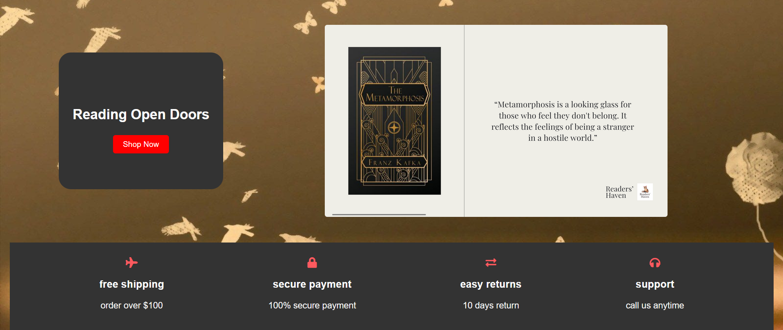

**EXPLANATION:**

**<div class="content">**: This division contains the main content for this section.

* **<h3>Reading Open Doors</h3>**: A heading that likely conveys the theme or message of the section.
* **<center>**: This tag centers the enclosed content (though it's deprecated; CSS is preferred for centering).

**<a href="#" class="btn">shop now</a>**: A call-to-action button that directs users to shop, styled with the class "btn".

* + **<span class="ribbon">75% Off</span>**: A decorative span indicating a discount, likely styled to stand out (like a ribbon).
* **<section class="icon-container">**: Defines a section designed to hold various icons, each with associated information.
* Each **<div class="icon-item">** represents an individual icon feature:
* **<i class="fa fa-plane"></i>**: Utilizes Font Awesome icons. Here, it represents "free shipping".
* **<div class="content">**: Contains the text for each feature.
  + **<h3>**: A heading describing the feature (e.g., "free shipping").
  + **<p>**: A paragraph providing additional details (e.g., "order over $100").

**CSS CODE:**

.home {

    display: flex;

    justify-content: space-around;

    align-items: center;

    padding: 20px 20px;

    background-color: #3a3a3a; /* Dark background */

    color: #ffffff; /* White text */

}

.home .content {

    max-width: 600px;

}

.home h3 {

    font-size: 36px;

    margin-bottom: 20px;

}

.home .btn {

    background-color: #ff5a5f;

    color: #ffffff;

    padding: 10px 20px;

    border-radius: 5px;

    text-decoration: none;

    font-size: 16px;

    transition: background 0.3s;

}

.home .btn:hover {

    background-color: #ff3b3f;

}

.home .image img {

    max-width: 500px;

    border-radius: 10px;

    box-shadow: 0 4px 10px rgba(0, 0, 0, 0.1);

}

/* Icon Section */

.icon-container {

    display: flex;

    justify-content: space-around;

    align-items: center;

    background-color: #333333;

    padding: 30px 0px;

    color: #ffffff;

}

.icon-container i {

    text-align: center;

    font-size: 36px;

    color: #ff5a5f;

    margin: 0px 10px 20px 0px;

}

.icon-container h3 {

    font-size: 18px;

    margin-bottom: 10px;

}

.icon-container p {

    font-size: 14px;

}

**HTML CODE:**

<section class="features" id="features">

    <h1 class="heading"><span> featured books</span></h1>

    <div class="featured-slider">

        <div class="box">

            <div class="icons">

                <a href="#" class="fa fa-search"></a>

                <a href="#" class="fa fa-eye"></a>

                <a href="#" class="fa fa-heart"></a>

                </div>

                <div class="image">

                    <img src="https://fiverr-res.cloudinary.com/images/t_main1,q_auto,f_auto,q_auto,f_auto/gigs/340795550/original/6c3009470b039ff50ed4b6fa78ecc911c45929f6/do-unique-and-3d-book-cover.png" alt="book">

                </div>

                <div class="content">

                    <h3>featured books</h3>

                    <div class="price">$15.99<span>$20.99</span></div>

                    <a href="#" class="btn">add to cart</a>

                </div>

        </div>

**OUTPUT:**

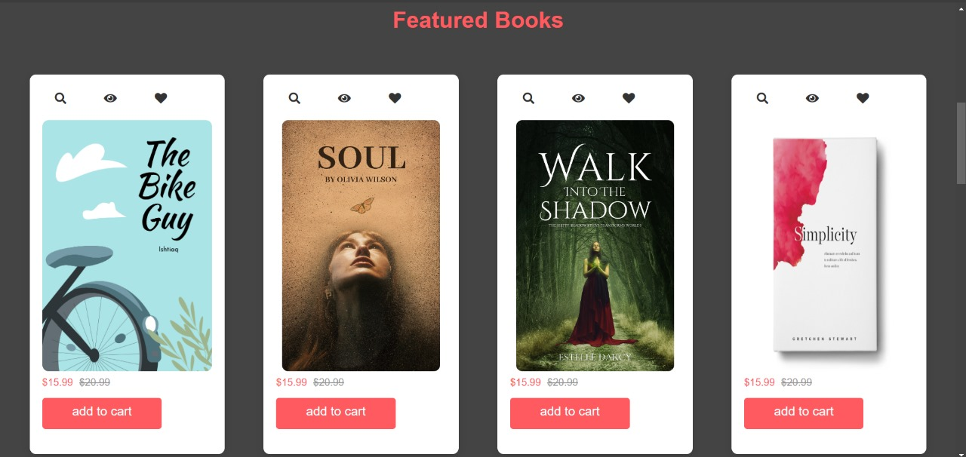

#### EXPLANATION:

* **<section class="features" id="features">**:
* This tag defines a section of the webpage dedicated to featured books.
* The class "features" can be used for styling, while the ID "features" allows for specific targeting with CSS or JavaScript.
* **<h1 class="heading"><span>featured books</span></h1>**:
* This heading introduces the section, indicating that it showcases featured books.
* The <span> tag can be used to style just the text "featured books" if desired.
* **<div class="featured-slider">**:
* This division likely serves as a container for a slider or gallery of featured books. It can enable scrolling or transitioning between different books, depending on additional JavaScript or CSS.

#### CSS CODE:

.features {

    padding: 50px 0;

    background-color: #444444;

    color: #ffffff;

}

.features .heading {

    text-align: center;

    font-size: 36px;

    margin-bottom: 50px;

}

.features .heading span {

    color: #ff5a5f;

}

.featured-slider {

    display: flex;

    justify-content: space-around;

    flex-wrap: wrap;

}

.featured-slider .box {

    background-color: #ffffff;

    color: #333;

    border-radius: 10px;

    padding: 20px;

    margin: 15px;

    max-width: 250px;

    box-shadow: 0 4px 15px rgba(0, 0, 0, 0.1);

    text-align: center;

    transition: transform 0.3s;

}

.featured-slider .box:hover {

    transform: translateY(-10px);

}

.featured-slider .icons {

    margin-bottom: 15px;

}

.featured-slider .icons a {

    color: #333;

    margin: 0 5px;

    font-size: 18px;

    transition: color 0.3s;

}

.featured-slider .icons a:hover {

    color: #ff5a5f;

}

.featured-slider .image img {

    max-width: 100%;

    border-radius: 10px;

    margin-bottom: 15px;

}

.featured-slider .content h3 {

    font-size: 18px;

    margin-bottom: 10px;

}

.featured-slider .price {

    font-size: 16px;

    color: #ff5a5f;

    margin-bottom: 15px;

}

.featured-slider .price span {

    text-decoration: line-through;

    color: #999;

    margin-left: 10px;

}

.featured-slider .btn {

    background-color: #ff5a5f;

    color: #ffffff;

    padding: 10px 20px;

    border-radius: 5px;

    text-decoration: none;

    font-size: 14px;

    transition: background 0.3s;

}

.featured-slider .btn:hover {

    background-color: #ff3b3f;

}

/* Media Query for Responsive Design */

@media (max-width: 768px) {

    .home {

        flex-direction: column;

        text-align: center;

    }

    .home .content {

        margin-bottom: 20px;

    }

    .icon-container {

        flex-direction: column;

        align-items: center;

    }

    .featured-slider {

        flex-direction: column;

        align-items: center;

    }

    .featured-slider .box {

        max-width: 90%;

    }

}

#### EXPLANATION:

#### <section class="deal">: This tag defines a section of the webpage dedicated to a special deal. The class "deal" allows for targeted styling and layout adjustments

**<div class="content">**: A division that contains the text and link related to the deal.

* **<h3>deal of the day</h3>**: This heading indicates that it’s a featured daily deal.
* **<h3>upto 50% off</h3>**: A second heading that emphasizes the discount, attracting customer attention.
* **<a href="#" claa="btn">shop now</a>**: A link styled as a button for users to click and shop.
* **<div class="image">**: This division contains the image associated with the deal.
  + **<img src="...**: Displays an image related to the deal, enhancing the visual appeal.
  + **alt=""**: The alt attribute is empty, which is not ideal for accessibility. It’s recommended to provide a description (e.g., alt="Promotional image for deal of the day").

#### HTML CODE:

    <section class="review" id="reviews">

        <h1 class="heading"> client's reviews</h1>

        <div class="reviews-slider">

                <div class="box">

                    <img src="https://plus.unsplash.com/premium_photo-1682144187125-b55e638cf286?fm=jpg&q=60&w=3000&ixlib=rb-4.0.3&ixid=M3wxMjA3fDB8MHxzZWFyY2h8MXx8bWVuJTIwcG9ydHJhaXR8ZW58MHx8MHx8fDA%3D" alt="">

                    <h3>john deo</h3>

                    <p>Lorem ipsum dolor sit amet consectetur adipisicing elit. Sed error esse voluptatem accusantium molestias mollitia fuga rem quisquam. Quo tempora culpa aut modi praesentium asperiores voluptates omnis eaque iste saepe.</p>

                    <div class="stars">

                        <i class="fa fa-star"></i>

                        <i class="fa fa-star"></i>

                        <i class="fa fa-star"></i>

                        <i class="fa fa-star-half-alt"></i>

                    </div>

                </div>

**EXPLANATION:**

* **<section class="review" id="reviews">**:
  + Defines a section for client reviews.
  + The class "review" can be used for styling, while the ID "reviews" allows for direct linking or targeting with CSS/JavaScript.
* **<div class="box">**: Represents an individual review entry.
* **Image**:
* **<img src="..." alt="">**: Displays a profile picture or avatar of the reviewer. The alt attribute should ideally contain a description (e.g., alt="Profile picture of John Deo").
* **Reviewer Name**:
* **<h3>john deo</h3>**: The name of the reviewer.
* **Review Text**:
* **<p>**: Contains the testimonial text, providing insights into the reviewer’s experience.
* **Star Ratings**: This division includes Font Awesome icons to represent the reviewer's rating:
* Three full stars and one half-star indicate a rating (likely around 3.5 out of 5)

**OUTPUT:**

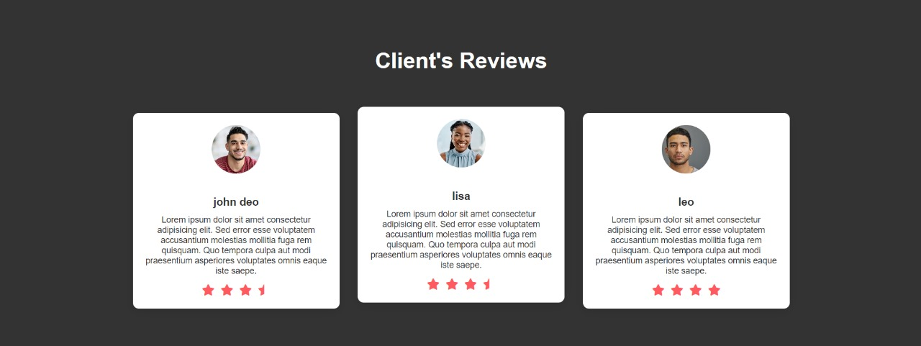

#### :CSS CODE:

review {

    background-color: #333333;

    color: #ffffff;

    padding: 50px 20px;

}

.review .heading {

    text-align: center;

    font-size: 36px;

    margin-bottom: 50px;

}

.reviews-slider {

    display: flex;

    flex-wrap: wrap;

    flex-direction: row;

    justify-content: center;

}

.reviews-slider .box {

    background-color: #ffffff;

    color: #333;

    border-radius: 10px;

    padding: 20px;

    margin: 15px;

    max-width: 300px;

    box-shadow: 0 4px 15px rgba(0, 0, 0, 0.1);

    text-align: center;

    transition: transform 0.3s;

}

.reviews-slider .box:hover {

    transform: translateY(-10px);

}

.reviews-slider .box img {

    border-radius: 50%;

    width: 80px;

    height: 80px;

    object-fit: cover;

    margin-bottom: 15px;

}

.reviews-slider .box h3 {

    font-size: 18px;

    margin-bottom: 10px;

}

.reviews-slider .box p {

    font-size: 14px;

    margin-bottom: 15px;

}

.reviews-slider .stars i {

    color: #ff5a5f;

    margin: 0 3px;

    font-size: 18px;

}

#### Conclusion with future scope:

#### In conclusion, online bookstores have revolutionized the way readers access literature, offering unparalleled convenience, a vast selection, and personalized recommendations. As technology continues to advance, these platforms are poised for further growth and innovation.

#### Future Scope

1. **Enhanced User Experience**: Continued improvements in user interfaces and personalized algorithms will make browsing and purchasing books more intuitive, tailoring suggestions to individual reading habits.
2. **Subscription Services**: The rise of subscription models will likely expand, offering readers curated selections based on their interests, fostering community and loyalty.
3. **Diverse Content Offerings**: Expansion into audiobooks, e-books, and self-publishing platforms will provide authors with more opportunities, while giving readers access to a wider variety of content.
4. **Global Reach**: Improved logistics and digital marketing strategies will enable online bookstores to reach underserved markets worldwide, providing access to literature in diverse languages and formats.

By embracing these trends, online bookstores can enhance their offerings and ensure they remain integral to the evolving literary landscape. The future holds exciting possibilities for readers and authors alike in this dynamic digital environment.